# 大疆SDK

<https://github.com/dji-sdk/Mobile-SDK-Android>

<https://developer.dji.com/cn/document/9ce3de9e-4a4c-42ec-9755-7c5cb4579ad3>

# 大疆 SDK UX

<https://github.com/cc-shifo/Mobile-UXSDK-Android>

## Android_UX_SDK_Release_Notes

该文件在所下载的SDK里面。重点关注已知问题。

## 功能

显示实时视频

获取飞机设备状态

允许用户查看和改变产品设置

基本功能，自动起飞降落，返航到起点。

* Show a live view of the camera feed
* Show product state (aircraft telemetry, battery level, signal strength, etc.)
* Allow the user to review and change product settings
* Have basic functionalities such as automatic take off, land, go home.

## 目的

加速开发

## 效果图

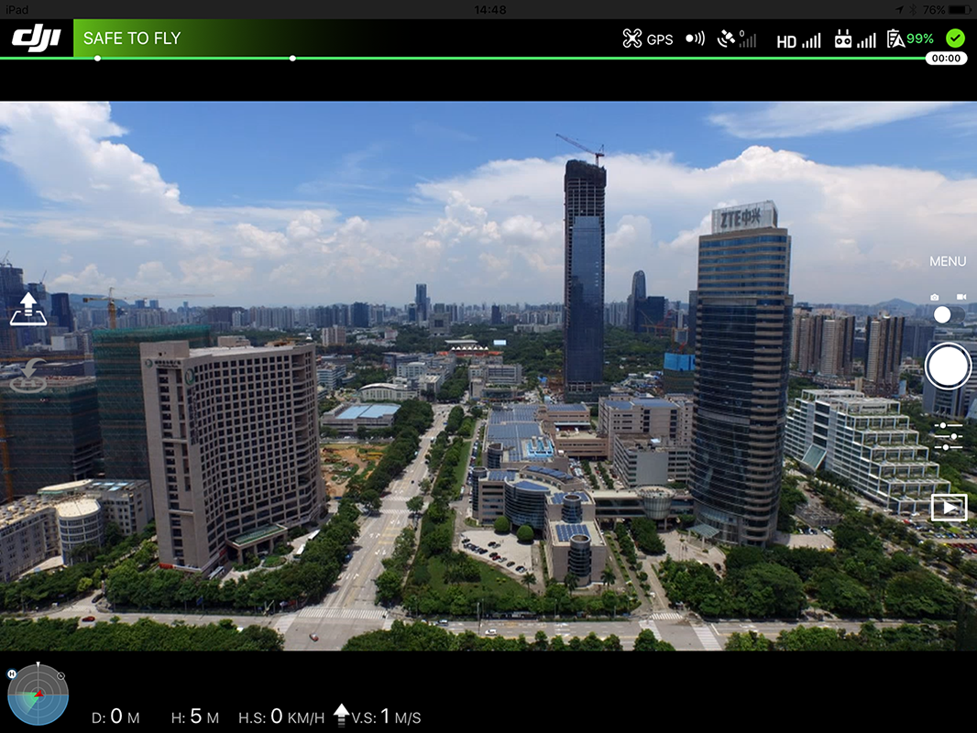

## 基本概念

### Widget小控件

主要提供状态显示和简单的控制。是UX SDK里最基本的显示元素。

### Panel面板控件

复杂界面里，面板相当于Widget的容器。

### 小控件的效果

|  |  |  |  |
| --- | --- | --- | --- |
| **Aircraft Battery Percentage** | **Flight Mode** | **Video Signal Strength** | **Return to Home Button** |
| https://terra-1-g.djicdn.com/84f990b0bbd145e6a3930de0c55d3b2b/admin/doc/7c0054df-1e69-4061-8033-6adef82c0129.png | https://terra-1-g.djicdn.com/84f990b0bbd145e6a3930de0c55d3b2b/admin/doc/824f0888-9303-44ca-b0f2-921d0707cb6e.png | https://terra-1-g.djicdn.com/84f990b0bbd145e6a3930de0c55d3b2b/admin/doc/74474f19-61e7-45bf-a8df-c4ded26b501c.png | https://terra-1-g.djicdn.com/84f990b0bbd145e6a3930de0c55d3b2b/admin/doc/67741264-1e10-428f-8d1b-595767b1734f.png |
|  |  |  |  |

### 面板效果

**Camera Settings Panel**

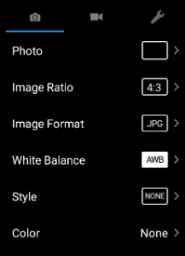

**Camera Exposure Settings Panel**

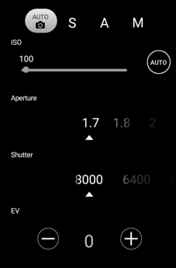

**Preflight Checklist**

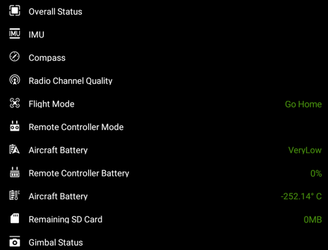

### 自定义原有的Widget

#### 改变小部件的外观

根据已存在的资源文件的命名规则添加资源文件

#### 改变小部件默认行为

继承Widget的默认行为，之后步骤：

1. 重写void initView(Context var1, AttributeSet var2, int var3)，不用调用它的父类函数。
2. 重写onXXXChange函数可以获取状态信息。
3. 重写performXXXAction函数可以改变默认行为。

#### 面板不允许自定义

# 5.0之后版本

更容易自定义所有UI元素(小部件)，通过扩展基类实现自定义小部件。开发指引：

<https://github.com/dji-sdk/Mobile-UXSDK-Beta-Android/wiki/UX-SDK-5.0-Overview>

# 开发指引

## 开发前准备工作

大疆UX SDK是基于大疆SDK和VideoPreviewer之上构建的，开发过程APP时需要一并引入他们。引入大疆SDK参见

1. <https://developer.dji.com/mobile-sdk/documentation/application-development-workflow/workflow-integrate.html#import-maven-dependency>
2. <https://github.com/dji-sdk/Mobile-SDK-Android>

在中国区使用大疆SDK，应用程序需要激活并且绑定到大疆账号上。对于没有激活或者绑定的或者大疆SDK小于4.1版本的应用，摄像头实时显示功能将被关闭，并且飞行区域被现在在直径100m，高度30m的范围内。绑定指引参见：

<https://developer.dji.com/document/9a028db0-fcbf-421b-bd6d-feadbc60a75d>

## 默认布局

[默认用例布局](res/default_layout.xml)

## 显示效果

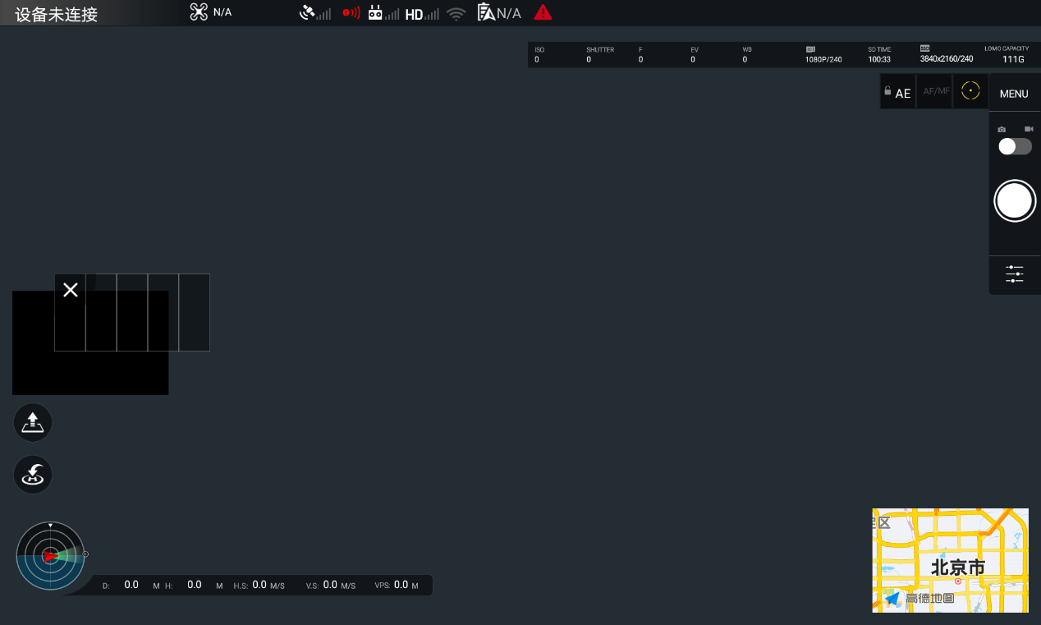

### FPVWidget and FPVOverlayWidgetWidget

to see first person view (FPV)

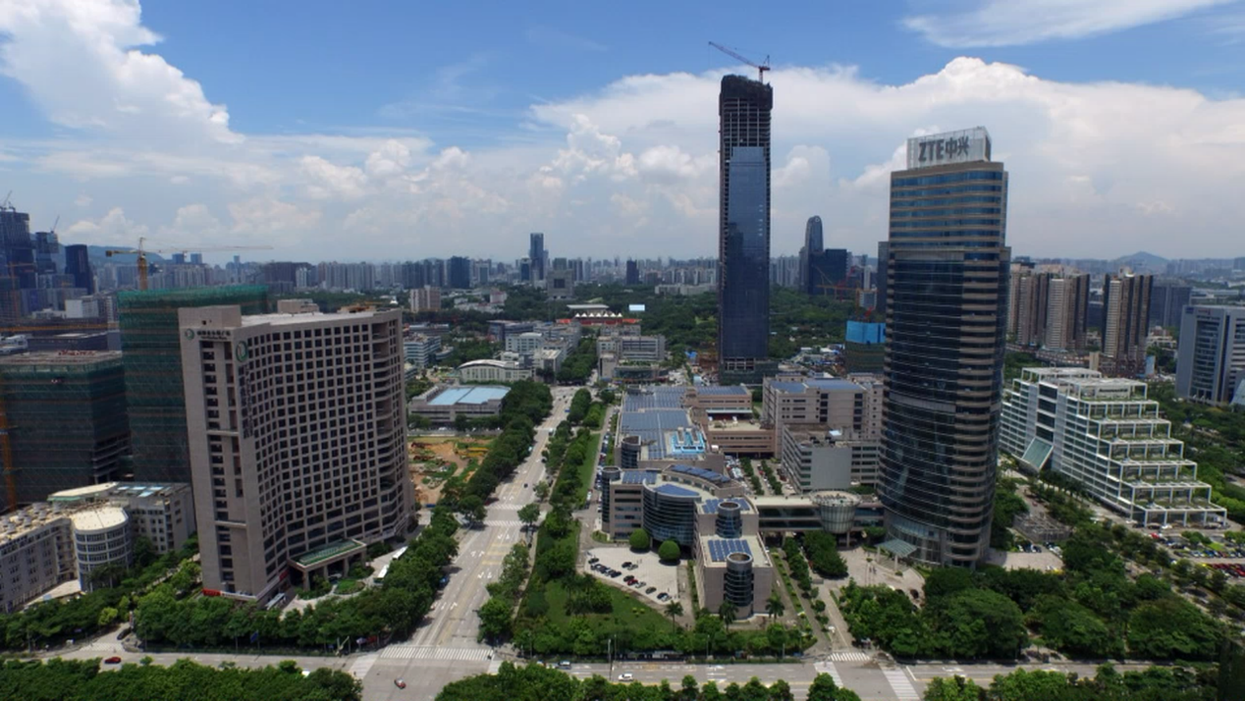

### PreFlightStatusWidget, FlightModeWidget, GPSSignalWidget, RemoteControlSignalWidget, etc.控件效果



### AutoExposureLockWidget, FocusExposureSwitchWidget, CameraConfigISOWidget, CameraConfigStorageWidget, etc. Also we add the dji.ui.widget.RemainingFlightTimeWidget element to show the remaining flight time widget below the top status bar widgets too. 控件效果



### the circular CompassWidget, the DistanceHomeWidget, the HorizontalVelocityWidget, the DistanceRCWidget, the VerticalVelocityWidget and the AltitudeWidget as shown below:

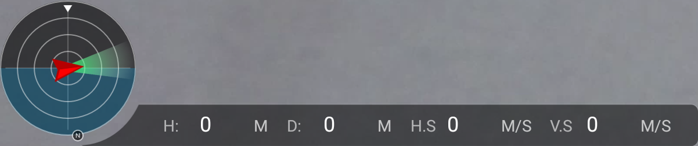

### TakeOffWidget and ReturnHomeWidget which will be shown as two buttons



### To add the CameraSettingExposurePanel, we add the dji.ui.panel.CameraSettingExposurePanel element and configure its attributes

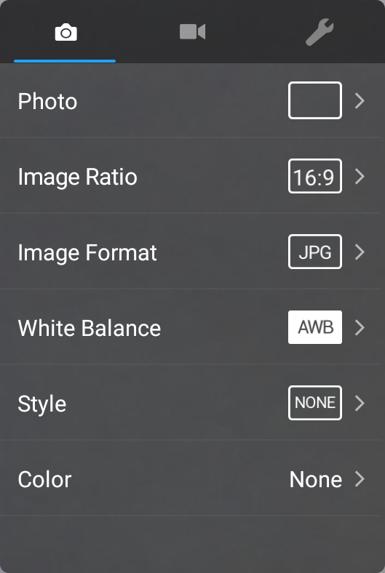

### To add the CameraSettingAdvancedPanel, we add the dji.ui.panel.CameraSettingAdvancedPanel element and configure its attributes

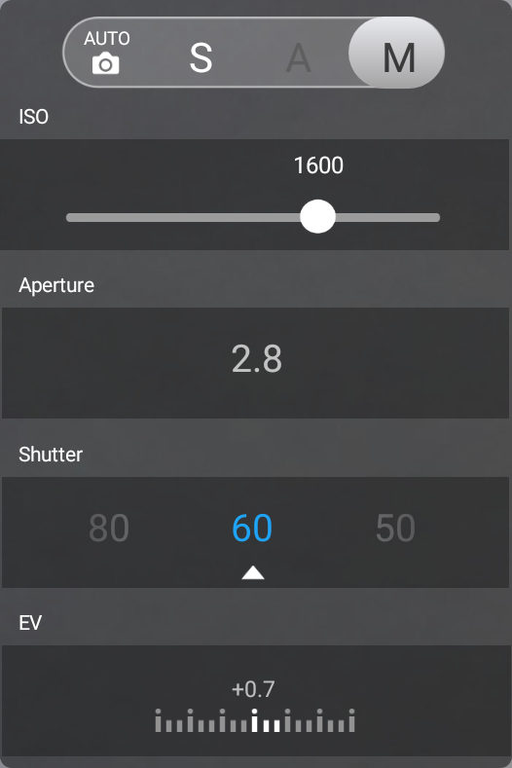

### PreFlightCheckListPanel element to create the PreFlightCheckListPanel. When user press on the PreFlightStatusWidget, it will show up below the top status bar.

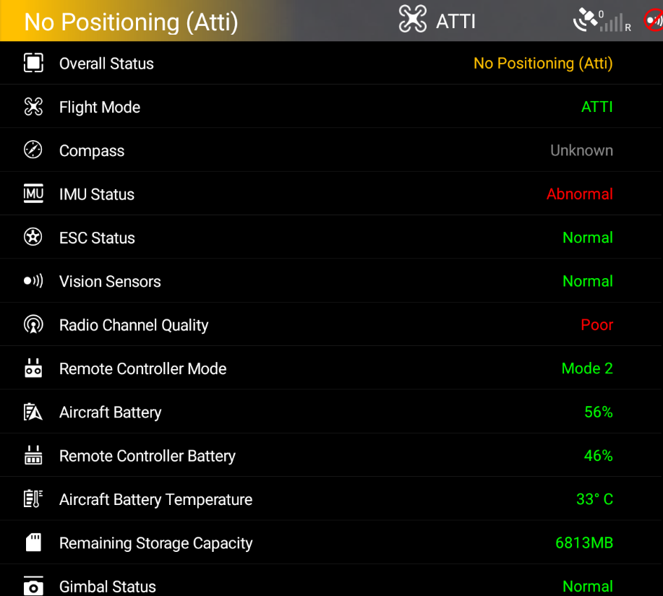

### DashboardWidget

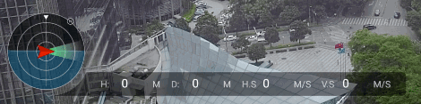

## 默认颜色配置

[res\default_color.xml](res/default_color.xml)

## 默认主题设置

[res\default_theme.xml](res/default_theme.xml)

发发呆

## 平台申请KEY注册APP

参见<https://developer.dji.com/document/2e5ae092-b0fa-4cbd-abe2-956f44253c12>

## Manifest.xml文件中配置KEY

<!--

ADD API_KEY HERE and make sure you

are connected to the Internet before

the app is launched

-->

<meta-data

android:name="com.dji.sdk.API_KEY"

android:value="" />

## 代码中注册APP

package com.dji.uxsdkdemo;

import android.app.Application;

import android.content.Context;

import com.secneo.sdk.Helper;

public class MApplication extends Application {

private DemoApplication demoApplication;

@Override

protected void attachBaseContext(Context paramContext) {

super.attachBaseContext(paramContext);

Helper.install(MApplication.this);

if (demoApplication == null) {

demoApplication = new DemoApplication();

demoApplication.setContext(this);

}

}

@Override

public void onCreate() {

super.onCreate();

demoApplication.onCreate();

}

}

## Application里检查权限，注册管理SDK监听

读电话状态权限，写外部存储器权限

[res\check permission in application.xml](res/check%20permission%20in%20application.xml)

## Manifest文件声明权限

[res\Manifest声明权限.xml](res/Manifest声明权限.xml)

## MainActiivty之前的配置

[res\MainActivity之前的Activity的配置.txt](res/MainActivity之前的Activity的配置.txt)

注意accessory_filter.xml从UX SDK的demo之中拷贝来。

## 代码动态申请权限

## 运行后效果（[gif效果](res/运行成功后.gif)）



## API手册

<https://developer.dji.com/api-reference/android-uilib-api/Widgets/DULFPVWidget.html>